[](https://www.google.co.il/url?sa=i&url=https://www.pinterest.com/pin/480126010252178900/&psig=AOvVaw2M8KIfxHh8B6FMjbhS7nbg&ust=1589555721032000&source=images&cd=vfe&ved=0CAIQjRxqFwoTCIC5-NXSs-kCFQAAAAAdAAAAABAD)

**חוברת הצביעה של**

**_______**

יצורים דמיוניים

[](https://www.google.co.il/url?sa=i&url=https://www.child-world.co.il/%D7%93%D7%A4%D7%99-%D7%A6%D7%91%D7%99%D7%A2%D7%94-%D7%97%D7%93-%D7%A7%D7%A8%D7%9F-28-%D7%93%D7%A4%D7%99-%D7%A6%D7%91%D7%99%D7%A2%D7%94-%D7%9C%D7%94%D7%93%D7%A4%D7%A1%D7%94-%D7%A9%D7%9C-%D7%97%D7%93/&psig=AOvVaw3o7aZoFZkDirIcf2RgrgLv&ust=1589553454367000&source=images&cd=vfe&ved=0CAIQjRxqFwoTCLj-wZnKs-kCFQAAAAAdAAAAABAZ)

[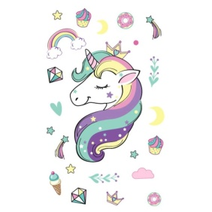](https://www.google.co.il/url?sa=i&url=https://zezol.co.il/%D7%A2%D7%9E%D7%99%D7%93-%D7%9C%D7%9E%D7%99%D7%9D-%D7%97%D7%93-%D7%A7%D7%A8%D7%9F-%D7%96%D7%9E%D7%A0%D7%99-%D7%9E%D7%93%D7%91%D7%A7%D7%95%D7%AA-%D7%A7%D7%A2%D7%A7%D7%95%D7%A2%D7%99%D7%9D-%D7%9E%D7%96/&psig=AOvVaw1-TLO3JDDvpfVIhVvC_7Lg&ust=1589556768158000&source=images&cd=vfe&ved=0CAIQjRxqFwoTCMCk8MfWs-kCFQAAAAAdAAAAABAR)[](https://www.google.co.il/url?sa=i&url=https://www.printime.co.il/2020/04/rainbocorn-coloring-pages.html&psig=AOvVaw3o7aZoFZkDirIcf2RgrgLv&ust=1589553454367000&source=images&cd=vfe&ved=0CAIQjRxqFwoTCLj-wZnKs-kCFQAAAAAdAAAAABAN)

[](https://www.google.co.il/url?sa=i&url=http://fantasywall.co.il/%D7%93%D7%92%D7%99%D7%9D/&psig=AOvVaw3qTjxXREFY5mFZ_DUmoJXL&ust=1589558475635000&source=images&cd=vfe&ved=0CAIQjRxqFwoTCMDq4Pjcs-kCFQAAAAAdAAAAABAR)

[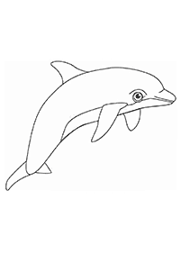](https://www.google.co.il/url?sa=i&url=https://www.pinterest.com/pin/436427020123868605/&psig=AOvVaw1HoZgY-kYFK3H3l_PW7DbB&ust=1589557775211000&source=images&cd=vfe&ved=0CAIQjRxqFwoTCPDR7qfas-kCFQAAAAAdAAAAABAd)עולם המים

[](https://www.google.co.il/url?sa=i&url=http://coloring-pages.co.il/animal-coloring-pages/fish-coloring-pages/Fish-Coloring-Pages1&psig=AOvVaw3qTjxXREFY5mFZ_DUmoJXL&ust=1589558475635000&source=images&cd=vfe&ved=0CAIQjRxqFwoTCMDq4Pjcs-kCFQAAAAAdAAAAABAf)[](https://www.google.co.il/url?sa=i&url=http://fantasywall.co.il/%D7%93%D7%92%D7%99%D7%9D/&psig=AOvVaw3qTjxXREFY5mFZ_DUmoJXL&ust=1589558475635000&source=images&cd=vfe&ved=0CAIQjRxqFwoTCMDq4Pjcs-kCFQAAAAAdAAAAABAR)[](https://www.google.co.il/url?sa=i&url=https://www.yo-yoo.co.il/coloring/bg.php?film%3D37&psig=AOvVaw1NXtQjr07heOiw5I9D-Sb_&ust=1589557994130000&source=images&cd=vfe&ved=0CAIQjRxqFwoTCKDE2Y_bs-kCFQAAAAAdAAAAABAD)[](https://www.google.co.il/url?sa=i&url=http://fantasywall.co.il/%D7%93%D7%92%D7%99%D7%9D/&psig=AOvVaw3qTjxXREFY5mFZ_DUmoJXL&ust=1589558475635000&source=images&cd=vfe&ved=0CAIQjRxqFwoTCMDq4Pjcs-kCFQAAAAAdAAAAABAR)

[](https://www.google.co.il/url?sa=i&url=http://fantasywall.co.il/%D7%93%D7%92%D7%99%D7%9D/&psig=AOvVaw3qTjxXREFY5mFZ_DUmoJXL&ust=1589558475635000&source=images&cd=vfe&ved=0CAIQjRxqFwoTCMDq4Pjcs-kCFQAAAAAdAAAAABAR)[](https://www.google.co.il/url?sa=i&url=http://www.xn--7dbbqer5d.co.il/%D7%93%D7%A4%D7%99-%D7%A6%D7%91%D7%99%D7%A2%D7%94/%D7%93%D7%A4%D7%99-%D7%A6%D7%91%D7%99%D7%A2%D7%94-%D7%93%D7%92%D7%99%D7%9D.html&psig=AOvVaw3x_QgKkbeiMDT3Oqnz4_wD&ust=1589571505006000&source=images&cd=vfe&ved=0CAIQjRxqFwoTCODRxLqNtOkCFQAAAAAdAAAAABAM)

[](https://www.google.co.il/url?sa=i&url=http://fantasywall.co.il/%D7%93%D7%92%D7%99%D7%9D/&psig=AOvVaw3qTjxXREFY5mFZ_DUmoJXL&ust=1589558475635000&source=images&cd=vfe&ved=0CAIQjRxqFwoTCMDq4Pjcs-kCFQAAAAAdAAAAABAR)

[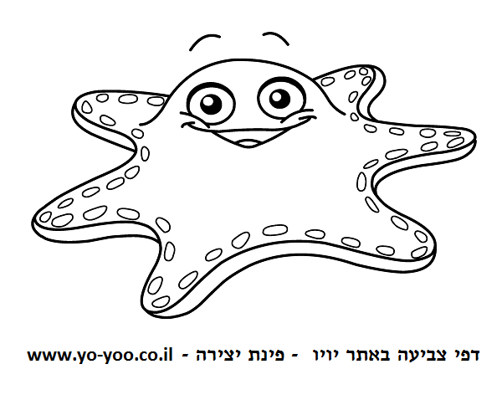](https://www.google.co.il/url?sa=i&url=https://www.yo-yoo.co.il/coloring/?page%3D2&psig=AOvVaw3x_QgKkbeiMDT3Oqnz4_wD&ust=1589571505006000&source=images&cd=vfe&ved=0CAIQjRxqFwoTCODRxLqNtOkCFQAAAAAdAAAAABAD)

[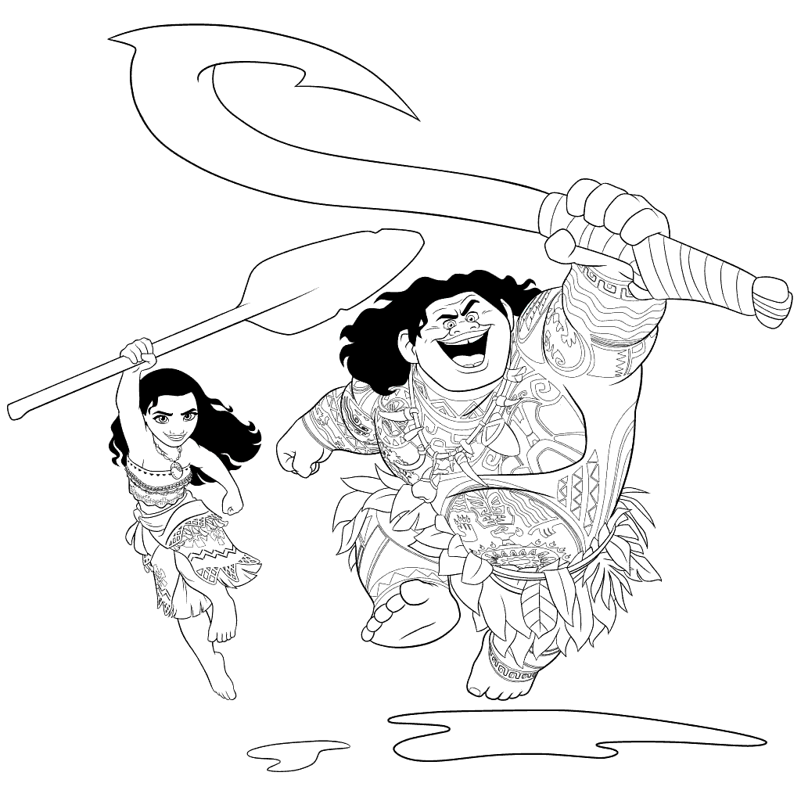](https://www.google.co.il/url?sa=i&url=https://www.child-world.co.il/%D7%93%D7%A4%D7%99-%D7%A6%D7%91%D7%99%D7%A2%D7%94-%D7%9E%D7%95%D7%90%D7%A0%D7%94/&psig=AOvVaw0eCFKAE8n5YwouxAY66fal&ust=1589559516925000&source=images&cd=vfe&ved=0CAIQjRxqFwoTCOiw6ungs-kCFQAAAAAdAAAAABAD)**עולם האגדות**

[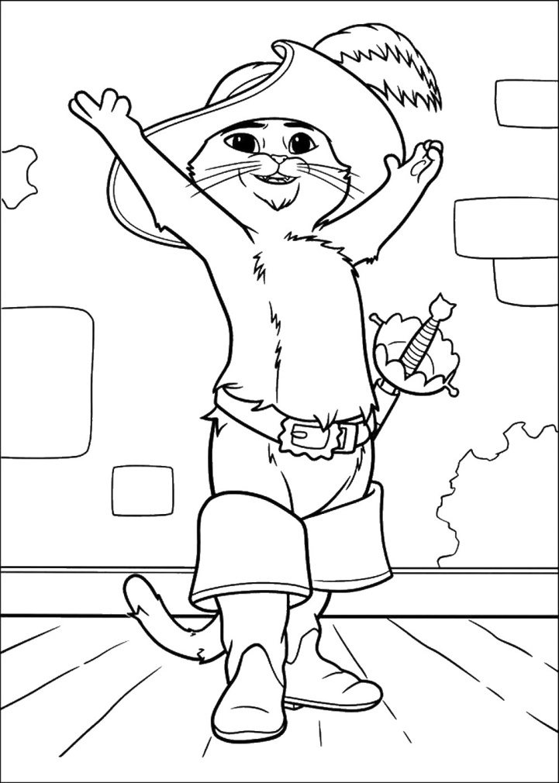](https://www.google.co.il/url?sa=i&url=https://www.coloring4fun.com/%D7%94%D7%97%D7%AA%D7%95%D7%9C-%D7%91%D7%9E%D7%92%D7%A4%D7%99%D7%99%D7%9D/&psig=AOvVaw1EkOsAziCiDussfhbEYMh7&ust=1589559717703000&source=images&cd=vfe&ved=0CAIQjRxqFwoTCKCJ4fDhs-kCFQAAAAAdAAAAABAD)[](https://www.google.co.il/url?sa=i&url=http://www.xn--7dbbqer5d.co.il/%D7%93%D7%A4%D7%99-%D7%A6%D7%91%D7%99%D7%A2%D7%94/%D7%93%D7%A4%D7%99-%D7%A6%D7%91%D7%99%D7%A2%D7%94-%D7%A4%D7%99%D7%A0%D7%95%D7%A7%D7%99%D7%95.html&psig=AOvVaw3BcQ6UxRxXhjRph4V8rPID&ust=1589559760040000&source=images&cd=vfe&ved=0CAIQjRxqFwoTCMDc5dvhs-kCFQAAAAAdAAAAABAD)

דמויות מתוכניות טלויזיה

[](https://www.google.co.il/url?sa=i&url=http://www.xn--7dbbqer5d.co.il/%D7%93%D7%A4%D7%99-%D7%A6%D7%91%D7%99%D7%A2%D7%94/%D7%93%D7%A4%D7%99-%D7%A6%D7%91%D7%99%D7%A2%D7%94-%D7%9C%D7%A7%D7%99%D7%A5.html&psig=AOvVaw3yYUSGNVI6DpLulwCQY7fA&ust=1589572268534000&source=images&cd=vfe&ved=0CAIQjRxqFwoTCLi42MyRtOkCFQAAAAAdAAAAABAD)[](https://www.google.co.il/url?sa=i&url=https://dapey-avoda.info/gan/%D7%93%D7%A4%D7%99-%D7%A6%D7%91%D7%99%D7%A2%D7%94-%D7%9E%D7%99%D7%A0%D7%99%D7%95%D7%A0%D7%99%D7%9D/&psig=AOvVaw0HrF3DVXYNqPl_JntEw8m8&ust=1589572772856000&source=images&cd=vfe&ved=0CAIQjRxqFwoTCJDC1qWStOkCFQAAAAAdAAAAABAD)

[](https://www.google.co.il/url?sa=i&url=http://www.xn--7dbbqer5d.co.il/%D7%93%D7%A4%D7%99-%D7%A6%D7%91%D7%99%D7%A2%D7%94/%D7%93%D7%A4%D7%99-%D7%A6%D7%91%D7%99%D7%A2%D7%94-%D7%A1%D7%9E%D7%99-%D7%94%D7%9B%D7%91%D7%90%D7%99.html&psig=AOvVaw3pWzm4Ix9mj3NkVZjzsRja&ust=1589572859604000&source=images&cd=vfe&ved=0CAIQjRxqFwoTCOjn4b-StOkCFQAAAAAdAAAAABAD)

[](https://www.google.co.il/url?sa=i&url=https://www.coloring4fun.com/%D7%90%D7%9C%D7%90%D7%93%D7%99%D7%9F-%D7%95%D7%9E%D7%A0%D7%95%D7%A8%D7%AA-%D7%94%D7%A7%D7%A1%D7%9E%D7%99%D7%9D/&psig=AOvVaw1aBfL2m9knR1RX6OXODuyJ&ust=1589571961385000&source=images&cd=vfe&ved=0CAIQjRxqFwoTCOCU65KPtOkCFQAAAAAdAAAAABAD)

[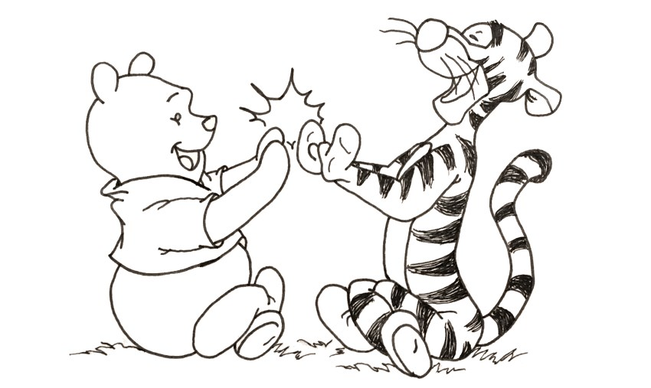](https://www.google.co.il/url?sa=i&url=http://ran-art.com/blogarticle07.html&psig=AOvVaw0xGeyIQLxLKfEs26hKFjzr&ust=1589572040556000&source=images&cd=vfe&ved=0CAIQjRxqFwoTCIiQ98CPtOkCFQAAAAAdAAAAABAD)

[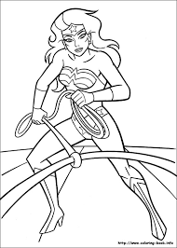](https://www.google.co.il/url?sa=i&url=http://www.posterim.co.il/%D7%A7%D7%98%D7%92%D7%95%D7%A8%D7%99%D7%94/%D7%95%D7%95%D7%A0%D7%93%D7%A8-%D7%95%D7%95%D7%9E%D7%9F&psig=AOvVaw1CUeNcMzSGvezRasac9BmE&ust=1589559913437000&source=images&cd=vfe&ved=0CAIQjRxqFwoTCKDH1KXis-kCFQAAAAAdAAAAABAD)**גיבורי על**

[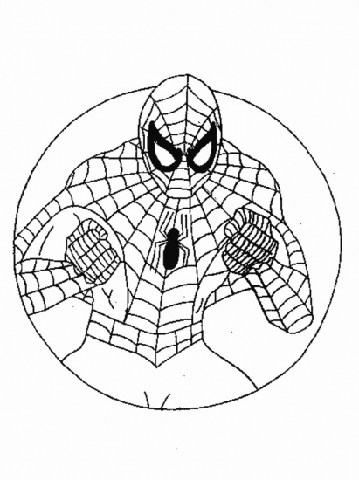](https://www.google.co.il/url?sa=i&url=http://www.yeldimdim.co.il/new/tcat/coloring-spiderman&psig=AOvVaw1CUeNcMzSGvezRasac9BmE&ust=1589559913437000&source=images&cd=vfe&ved=0CAIQjRxqFwoTCKDH1KXis-kCFQAAAAAdAAAAABAV)

[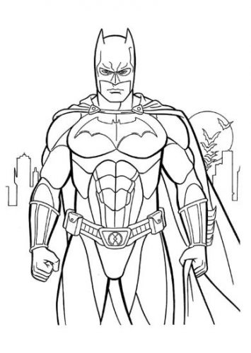](https://www.google.co.il/url?sa=i&url=https://colorpages.online/%D7%93%D7%A4%D7%99-%D7%A6%D7%91%D7%99%D7%A2%D7%94-%D7%92%D7%99%D7%91%D7%95%D7%A8%D7%99-%D7%A2%D7%9C/&psig=AOvVaw1CUeNcMzSGvezRasac9BmE&ust=1589559913437000&source=images&cd=vfe&ved=0CAIQjRxqFwoTCKDH1KXis-kCFQAAAAAdAAAAABAP)

[](https://www.google.co.il/url?sa=i&url=https://www.paintpages.co.il/%D7%93%D7%A4%D7%99-%D7%A6%D7%91%D7%99%D7%A2%D7%94-%D7%9C%D7%A7%D7%99%D7%A5/&psig=AOvVaw3CzmjaV-GVM0snyQJgpmiI&ust=1589561194823000&source=images&cd=vfe&ved=0CAIQjRxqFwoTCJixqIfns-kCFQAAAAAdAAAAABAD)**קיץ**

[](https://www.google.co.il/url?sa=i&url=https://www.kondor.co.il/%D7%9B%D7%93%D7%95%D7%A8_%D7%99%D7%9D_40_%D7%A1%D7%9E&psig=AOvVaw2VQcVyFNSLlKsDbwIyXfYg&ust=1589564094464000&source=images&cd=vfe&ved=0CAIQjRxqFwoTCPDl6uzxs-kCFQAAAAAdAAAAABAD)

[](https://www.google.co.il/url?sa=i&url=https://www.kondor.co.il/%D7%9B%D7%93%D7%95%D7%A8_%D7%99%D7%9D_40_%D7%A1%D7%9E&psig=AOvVaw2VQcVyFNSLlKsDbwIyXfYg&ust=1589564094464000&source=images&cd=vfe&ved=0CAIQjRxqFwoTCPDl6uzxs-kCFQAAAAAdAAAAABAD)[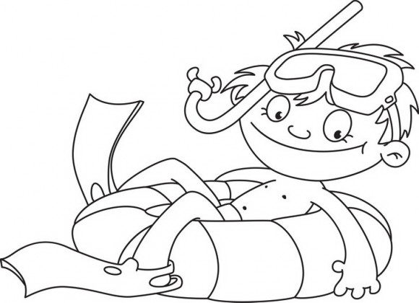](https://www.google.co.il/url?sa=i&url=https://coloring.co.il/940/&psig=AOvVaw2P7b19nUcDoTAYuFC5ot8y&ust=1589561900670000&source=images&cd=vfe&ved=0CAIQjRxqFwoTCIjqiurus-kCFQAAAAAdAAAAABAD)[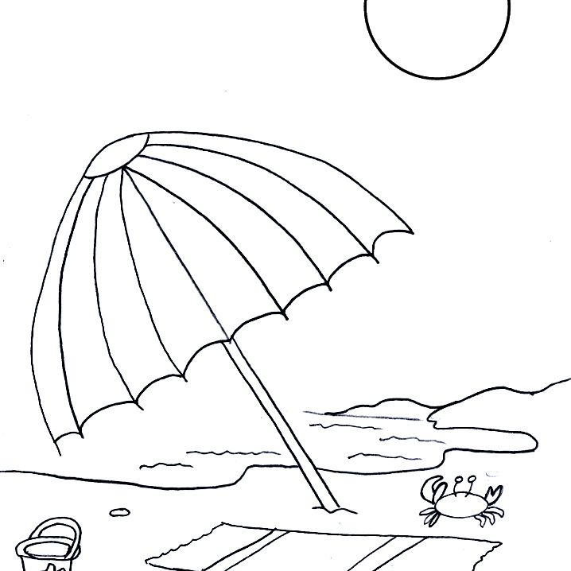](https://www.google.co.il/url?sa=i&url=https://iw.todoinfor.com/243-free-summer-coloring-pages&psig=AOvVaw1vYhsWoDt0lcBKjgPcPVXx&ust=1589563442647000&source=images&cd=vfe&ved=0CAIQjRxqFwoTCMjtq6jws-kCFQAAAAAdAAAAABAD)

**מאכלי קיץ**

[](https://www.google.co.il/url?sa=i&url=https://www.coloring4fun.com/%D7%92%D7%9C%D7%99%D7%93%D7%94/icecream_01/&psig=AOvVaw2n62cmXcsIfmpaOlPXTHcZ&ust=1589565801745000&source=images&cd=vfe&ved=0CAIQjRxqFwoTCIDwgqD4s-kCFQAAAAAdAAAAABAD)[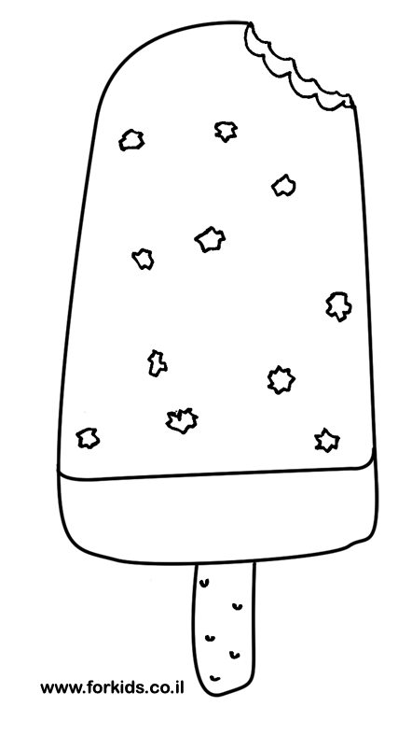](https://www.google.co.il/url?sa=i&url=https://www.forkids.co.il/tag/%D7%93%D7%A4%D7%99-%D7%A6%D7%91%D7%99%D7%A2%D7%94-%D7%92%D7%9C%D7%99%D7%93%D7%94/&psig=AOvVaw2S9VXplAF8ca2u61yn3ybe&ust=1589565626919000&source=images&cd=vfe&ved=0CAIQjRxqFwoTCMCR9Mb3s-kCFQAAAAAdAAAAABAK)

[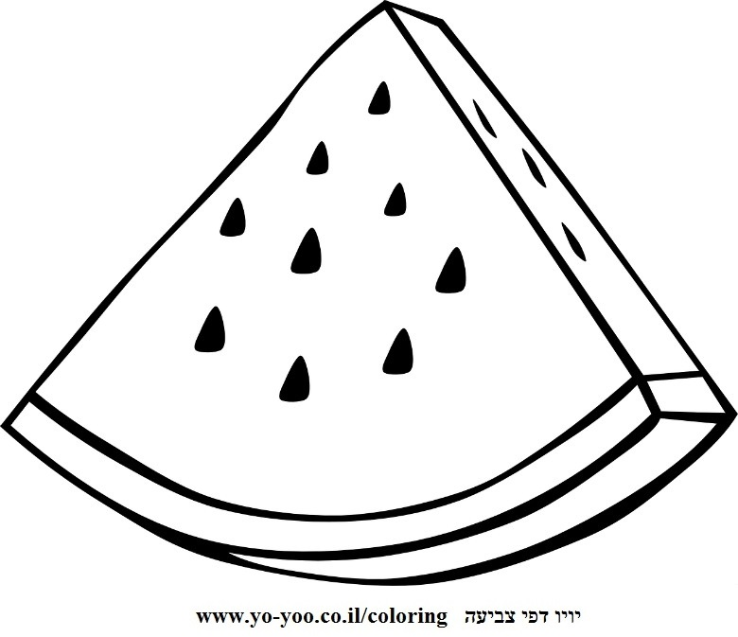](https://www.google.co.il/url?sa=i&url=https://www.yo-yoo.co.il/coloring/index.php?cat%3D22&psig=AOvVaw2S9VXplAF8ca2u61yn3ybe&ust=1589565626919000&source=images&cd=vfe&ved=0CAIQjRxqFwoTCMCR9Mb3s-kCFQAAAAAdAAAAABAD)

**בעלי חיים**

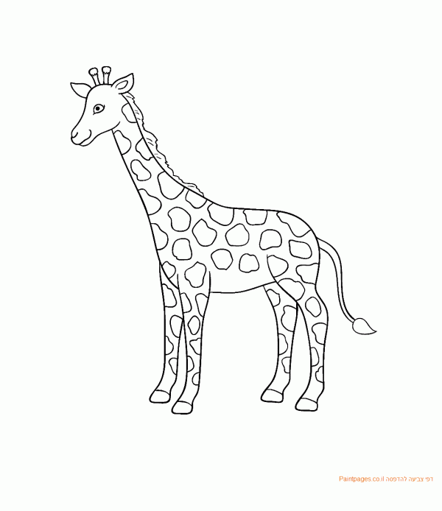

[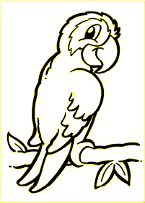](https://www.google.co.il/url?sa=i&url=https://www.prog.co.il/threads/%D7%96%D7%A7%D7%95%D7%A7%D7%94-%D7%9C%D7%A6%D7%99%D7%95%D7%A8-%D7%9E%D7%95%D7%A6%D7%9C%D7%97-%D7%A9%D7%9C-%D7%AA%D7%95%D7%9B%D7%99-%D7%9C%D7%A6%D7%91%D7%99%D7%A2%D7%94.433399/&psig=AOvVaw1msrnmvHEgkGXB9MnowGIi&ust=1589566377919000&source=images&cd=vfe&ved=0CAIQjRxqFwoTCNiazqz6s-kCFQAAAAAdAAAAABAD)

[](https://www.google.co.il/url?sa=i&url=http://www.xn--7dbbqer5d.co.il/%D7%93%D7%A4%D7%99-%D7%A6%D7%91%D7%99%D7%A2%D7%94/%D7%93%D7%A4%D7%99-%D7%A6%D7%91%D7%99%D7%A2%D7%94-%D7%9B%D7%9C%D7%91%D7%99%D7%9D.html&psig=AOvVaw0-ZPTq8xqWLNbpLCXjdyOt&ust=1589566005474000&source=images&cd=vfe&ved=0CAIQjRxqFwoTCIjP8YD5s-kCFQAAAAAdAAAAABAD)

[](https://www.google.co.il/url?sa=i&url=https://www.yo-yoo.co.il/coloring/index.php?cat%3D6&psig=AOvVaw2xLRyVfMXDzU7AYvKIXH7N&ust=1589566557342000&source=images&cd=vfe&ved=0CAIQjRxqFwoTCLDemIL7s-kCFQAAAAAdAAAAABAD)

**כלי תחבורה**

[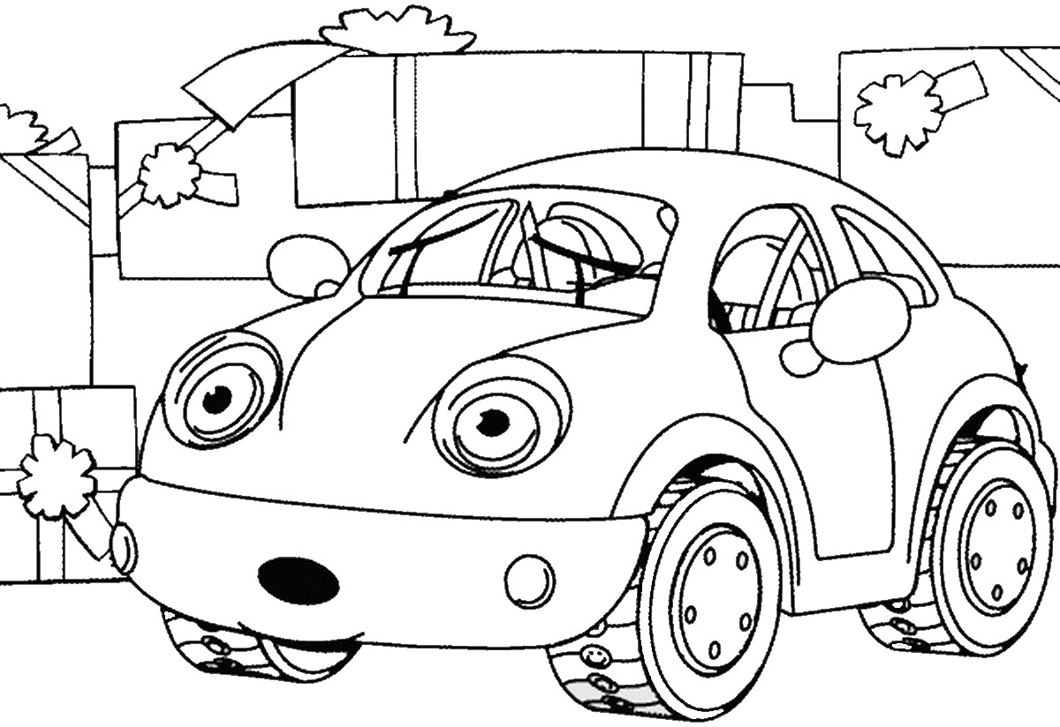](https://www.google.co.il/url?sa=i&url=https://www.coloring4fun.com/%D7%9E%D7%9B%D7%95%D7%A0%D7%99%D7%95%D7%AA/&psig=AOvVaw3q7KHUJC0-vf9ccXXMtmoG&ust=1589566777711000&source=images&cd=vfe&ved=0CAIQjRxqFwoTCOiL8fv7s-kCFQAAAAAdAAAAABAV)[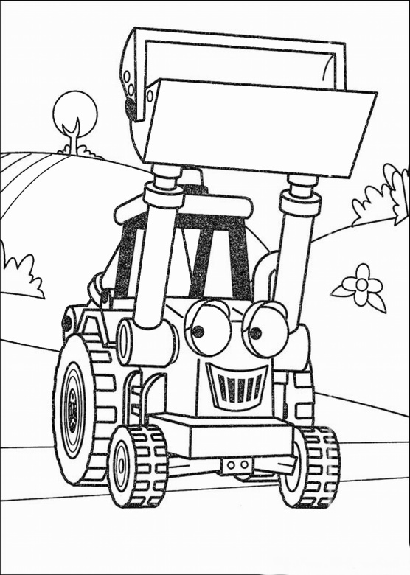](https://www.google.co.il/url?sa=i&url=https://www.coloring4fun.com/%D7%91%D7%95%D7%91-%D7%94%D7%91%D7%A0%D7%90%D7%99/&psig=AOvVaw3q7KHUJC0-vf9ccXXMtmoG&ust=1589566777711000&source=images&cd=vfe&ved=0CAIQjRxqFwoTCOiL8fv7s-kCFQAAAAAdAAAAABAJ)

[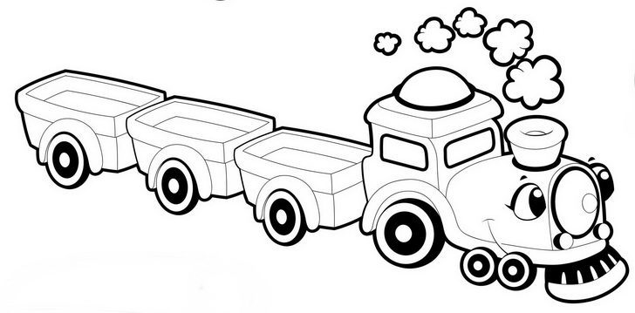](https://www.google.co.il/url?sa=i&url=https://coloring.co.il/category/%D7%93%D7%A4%D7%99-%D7%A6%D7%91%D7%99%D7%A2%D7%94-%D7%9C%D7%91%D7%A0%D7%99%D7%9D/&psig=AOvVaw3q7KHUJC0-vf9ccXXMtmoG&ust=1589566777711000&source=images&cd=vfe&ved=0CAIQjRxqFwoTCOiL8fv7s-kCFQAAAAAdAAAAABAD)

[](https://www.google.co.il/url?sa=i&url=http://www.baba-mail.co.il/content.aspx?emailid%3D23606&psig=AOvVaw2d_YS5Vs1js_7mUmajXqyb&ust=1589573940086000&source=images&cd=vfe&ved=0CAIQjRxqFwoTCJCmgfCWtOkCFQAAAAAdAAAAABAK)**כלי תעופה**

[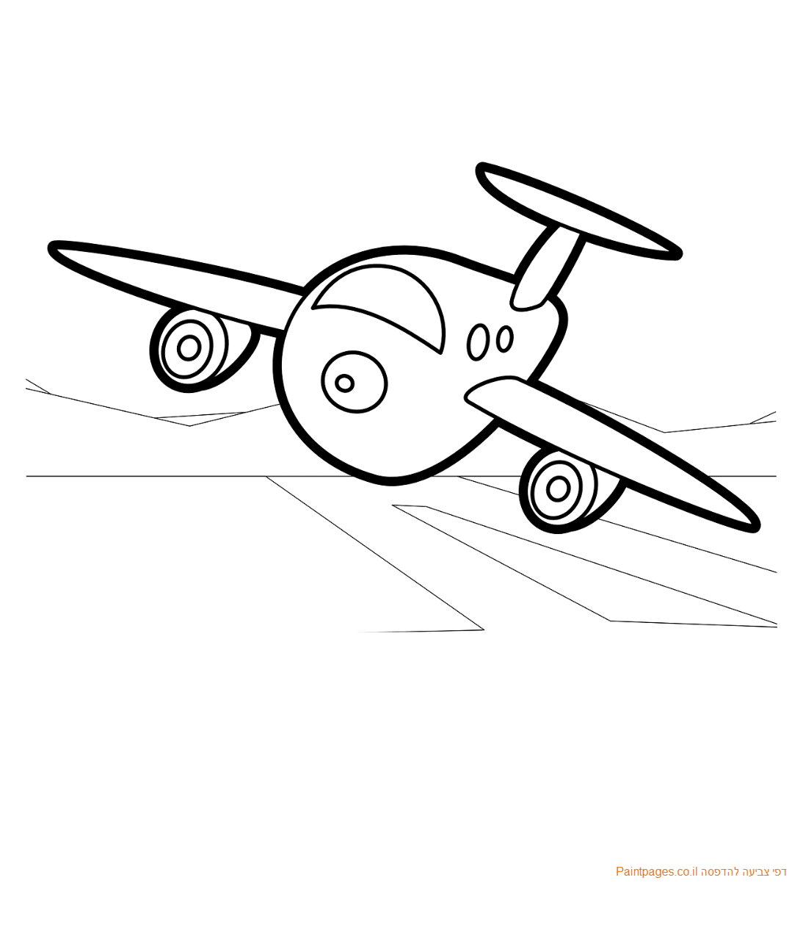](https://www.google.co.il/url?sa=i&url=https://www.paintpages.co.il/%D7%93%D7%A4%D7%99-%D7%A6%D7%91%D7%99%D7%A2%D7%94-%D7%AA%D7%A2%D7%95%D7%A4%D7%94/&psig=AOvVaw3dVtoIghnnGGLc8g8K7a7Y&ust=1589573104751000&source=images&cd=vfe&ved=0CAIQjRxqFwoTCLDXzbSTtOkCFQAAAAAdAAAAABAD)

[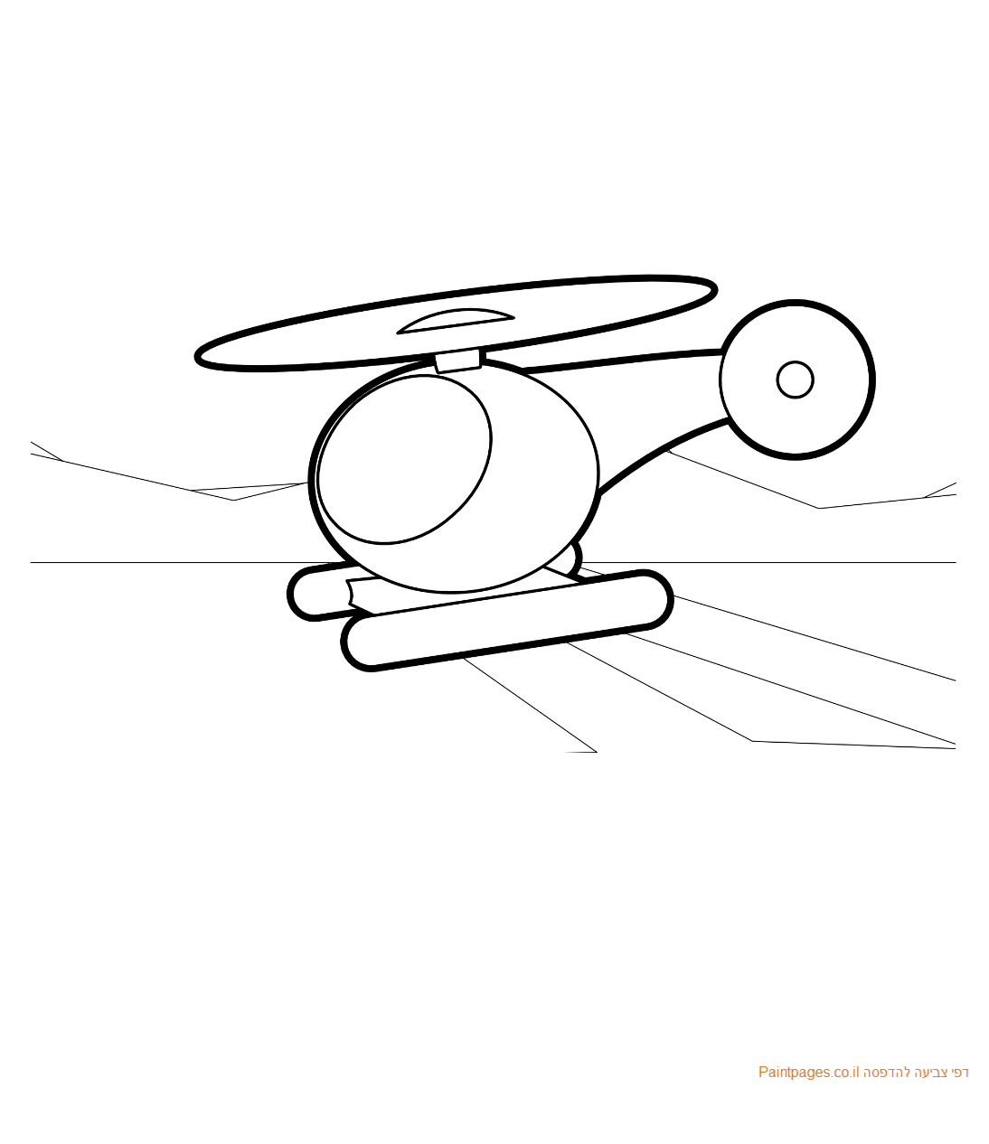](https://www.google.co.il/url?sa=i&url=https://www.paintpages.co.il/%D7%93%D7%A4%D7%99-%D7%A6%D7%91%D7%99%D7%A2%D7%94-%D7%AA%D7%A2%D7%95%D7%A4%D7%94/&psig=AOvVaw3dVtoIghnnGGLc8g8K7a7Y&ust=1589573104751000&source=images&cd=vfe&ved=0CAIQjRxqFwoTCLDXzbSTtOkCFQAAAAAdAAAAABAI)

[](https://www.google.co.il/url?sa=i&url=https://gameoffun.co.il/coloring-pages/&psig=AOvVaw1ctGScfSjnPbwg76XacAdX&ust=1589574210948000&source=images&cd=vfe&ved=0CAIQjRxqFwoTCIievMiXtOkCFQAAAAAdAAAAABAE)**כלי נגינה**

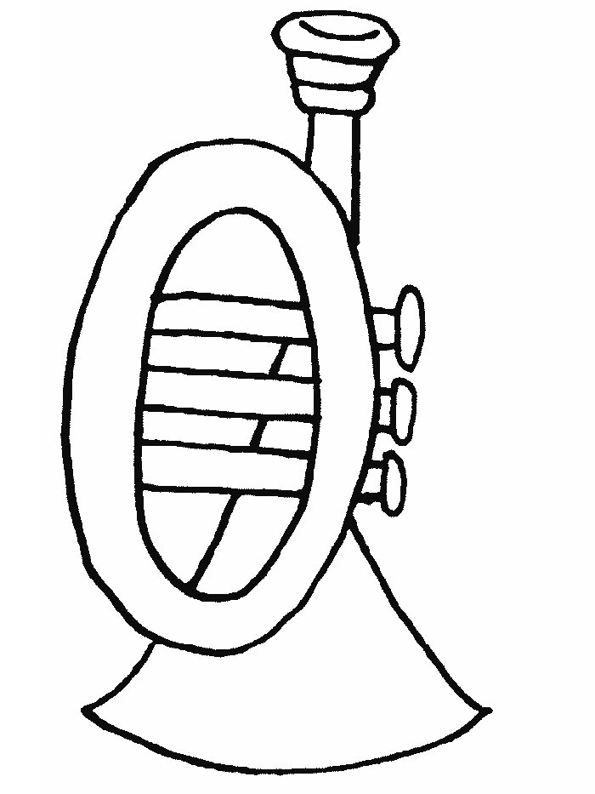

**עונות**

|  |  |
| --- | --- |
| **אביב**  [עץ דובדבן, עץ גודגדן - משתלת ויניק](https://www.google.co.il/url?sa=i&url=https://www.xn--8dbpf8bf.com/cherry/&psig=AOvVaw2L0YkXHuHsNovxOslsX5lQ&ust=1589574648909000&source=images&cd=vfe&ved=0CAIQjRxqFwoTCLDKk5uZtOkCFQAAAAAdAAAAABAD) | [קייטנות ואירועי קיץ- נאות בגין | מתנס רמלה | רשת מתנסים רמלה](https://www.google.co.il/url?sa=i&url=https://www.matnas-ramla.co.il/html5/?_id%3D12677%26did%3D4531%26g%3D12579%26sm%3D12677%26title%3D%F7%E9%E9%E8%F0%E5%FA%20%E5%E0%E9%F8%E5%F2%E9%20%F7%E9%F5-%20%F0%E0%E5%FA%20%E1%E2%E9%EF&psig=AOvVaw3A-1TpSICRXTadvUYKAuiD&ust=1589574790618000&source=images&cd=vfe&ved=0CAIQjRxqFwoTCKCyxNiZtOkCFQAAAAAdAAAAABAJ)**קיץ** |
| **סתיו**  [עיצוב תמונות ואלבומים: 1014 – עץ בשלכת | מתנה בתמונה](https://www.google.co.il/url?sa=i&url=https://printgift.co.il/product/1014/&psig=AOvVaw386pSBWV9ksUEDUNlx03oD&ust=1589574694313000&source=images&cd=vfe&ved=0CAIQjRxqFwoTCJCJm6qZtOkCFQAAAAAdAAAAABAD) | **חורף**[יורד גשם, שמח, ענן, קשת. יורד גשם, קשת, אופי, ציור היתולי, ענן, שמח.](https://www.google.co.il/url?sa=i&url=https://www.canstockphoto.co.il/%D7%99%D7%95%D7%A8%D7%93-%D7%92%D7%A9%D7%9D-%D7%A9%D7%9E%D7%97-%D7%A2%D7%A0%D7%9F-%D7%A7%D7%A9%D7%AA-17329990.html&psig=AOvVaw2A6jhqKph55UTpEs42pUhx&ust=1589574611365000&source=images&cd=vfe&ved=0CAIQjRxqFwoTCNCpnYOZtOkCFQAAAAAdAAAAABAD) |

[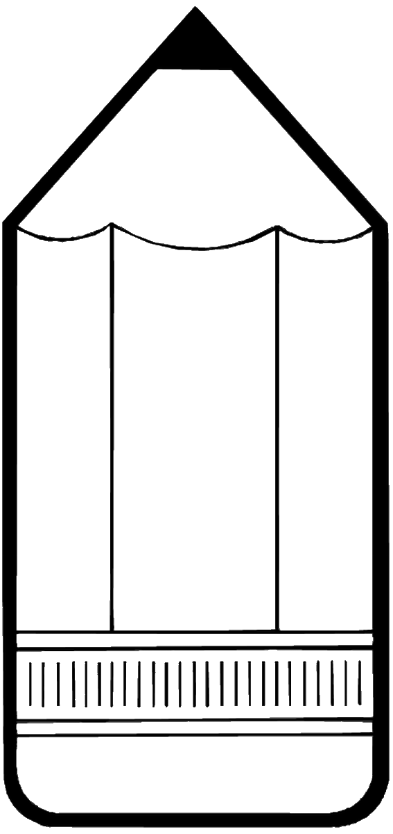](https://www.google.co.il/url?sa=i&url=https://www.coloring4fun.com/%D7%91%D7%99%D7%AA-%D7%A1%D7%A4%D7%A8/&psig=AOvVaw3aivJYC15xCsbv1Zrw1gAo&ust=1589568648560000&source=images&cd=vfe&ved=0CAIQjRxqFwoTCKCR1vGCtOkCFQAAAAAdAAAAABAR)**לימודים**

[](https://www.google.co.il/url?sa=i&url=https://www.coloring4fun.com/%D7%91%D7%99%D7%AA-%D7%A1%D7%A4%D7%A8/&psig=AOvVaw3aivJYC15xCsbv1Zrw1gAo&ust=1589568648560000&source=images&cd=vfe&ved=0CAIQjRxqFwoTCKCR1vGCtOkCFQAAAAAdAAAAABAD)[](https://www.google.co.il/url?sa=i&url=https://www.yo-yoo.co.il/coloring/index.php?cat%3D2&psig=AOvVaw3aivJYC15xCsbv1Zrw1gAo&ust=1589568648560000&source=images&cd=vfe&ved=0CAIQjRxqFwoTCKCR1vGCtOkCFQAAAAAdAAAAABAK)[](https://www.google.co.il/url?sa=i&url=https://www.coloring4fun.com/%D7%91%D7%99%D7%AA-%D7%A1%D7%A4%D7%A8/&psig=AOvVaw3aivJYC15xCsbv1Zrw1gAo&ust=1589568648560000&source=images&cd=vfe&ved=0CAIQjRxqFwoTCKCR1vGCtOkCFQAAAAAdAAAAABAR)

**ספורט**

[](https://www.google.co.il/url?sa=i&url=https://www.coloring4fun.com/%D7%A1%D7%A4%D7%95%D7%A8%D7%98/sports_cl_130/&psig=AOvVaw3nnoCt3Z-8SvoBZ6E9NL9c&ust=1589569131987000&source=images&cd=vfe&ved=0CAIQjRxqFwoTCLDCitCEtOkCFQAAAAAdAAAAABAD)[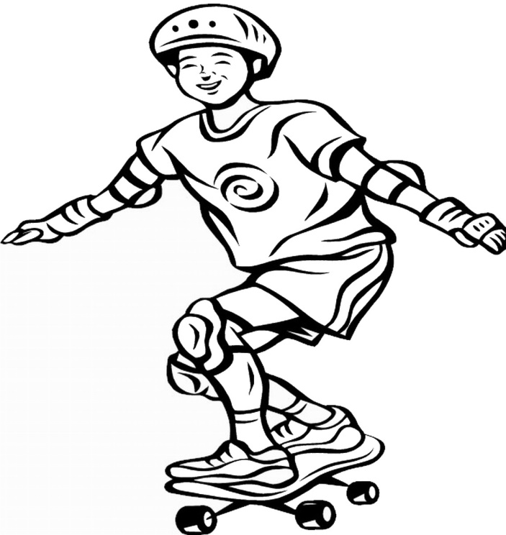](https://www.google.co.il/url?sa=i&url=https://www.coloring4fun.com/%D7%A1%D7%A7%D7%99%D7%99%D7%98%D7%91%D7%95%D7%A8%D7%93-%D7%93%D7%A4%D7%99-%D7%A6%D7%91%D7%99%D7%A2%D7%94/&psig=AOvVaw3nnoCt3Z-8SvoBZ6E9NL9c&ust=1589569131987000&source=images&cd=vfe&ved=0CAIQjRxqFwoTCLDCitCEtOkCFQAAAAAdAAAAABAQ)

[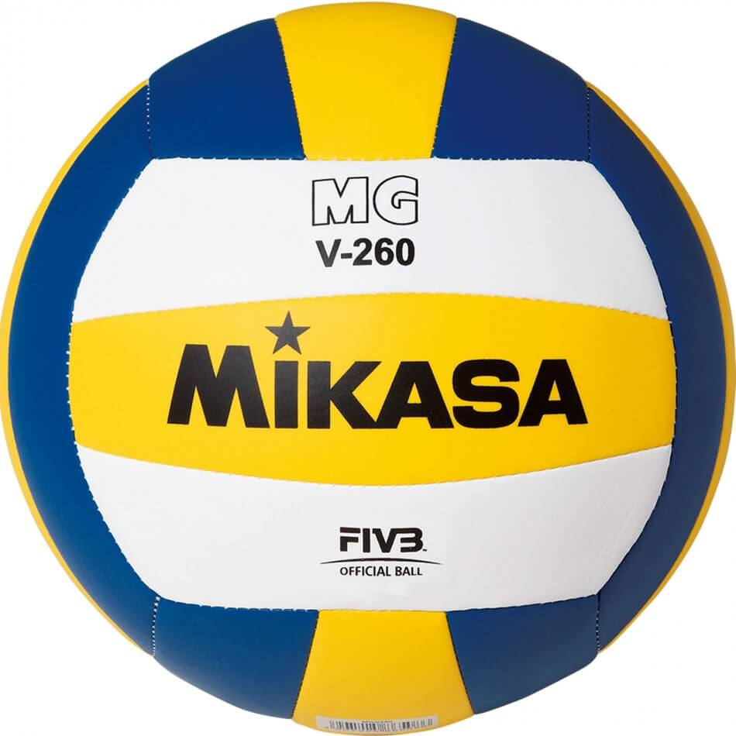](https://www.google.co.il/url?sa=i&url=https://megasport.co.il/kdvrep-mgv260-mikasa.html&psig=AOvVaw2HNxUL3184CE-umZ1L3nXY&ust=1589570313404000&source=images&cd=vfe&ved=0CAIQjRxqFwoTCPDw_IGJtOkCFQAAAAAdAAAAABAD)[](https://www.google.co.il/url?sa=i&url=http://www.sporty.co.il/product/%D7%9B%D7%93%D7%95%D7%A8-%D7%9B%D7%93%D7%95%D7%A8%D7%A1%D7%9C&psig=AOvVaw1vZUdT2ZXG91WFArWG7wqk&ust=1589570105964000&source=images&cd=vfe&ved=0CAIQjRxqFwoTCLiwme-ItOkCFQAAAAAdAAAAABAD)[](https://www.google.co.il/url?sa=i&url=http://www.sporty.co.il/product/%D7%9B%D7%93%D7%95%D7%A8-%D7%9B%D7%93%D7%95%D7%A8%D7%92%D7%9C-%D7%A6%D7%95%D7%A8%D7%94-%D7%A7%D7%9C%D7%90%D7%A1%D7%99%D7%AA&psig=AOvVaw3sbEp3P7KPgAOcQb37LoTA&ust=1589570025274000&source=images&cd=vfe&ved=0CAIQjRxqFwoTCNj-4oyItOkCFQAAAAAdAAAAABAD)

מנדלה

